✈️📄 AIRLINE RESERVATION SYSTEM — FINAL PROJECT REPORT

✅ Title
Mini Project: Airline Reservation System Using MySQL

✅ Objective
The objective of this project is to design and implement an Airline Reservation System using MySQL Workbench that can:
- Manage flights, customers, bookings, and seats,
- Maintain data integrity with foreign keys,
- Automate updates using triggers,
- Provide useful queries and views for easy reporting.

✅ Tools Used
- Database: MySQL
- IDE: MySQL Workbench
- Language: SQL (DDL, DML, Views, Triggers)

✅ Steps Followed
1️⃣ Schema Design
- Designed tables: Airports, Aircrafts, Flights, Customers, Bookings, Seats.
- Applied primary and foreign keys to normalize data.
2️⃣ Data Insertion
- Inserted realistic sample data for airports, aircrafts, flights, customers, and bookings.
3️⃣ Constraints
- Set unique IATA codes for airports.
- Used foreign keys to maintain relationships between flights, seats, customers, and bookings.
4️⃣ Triggers
- AfterBookingInsert to mark seats as booked automatically.
- AfterBookingCancel to free seats when a booking is cancelled.
5️⃣ Views
- Created AvailableSeats view to show all free seats.
6️⃣ Reports/Queries
- Query to find available seats.
- Query to search flights by route/date.
- Booking summary report with customer and flight details.

✅ Screenshots & Results
📌 1. Seats Table — Sample Data
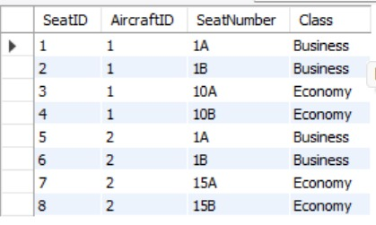
📌 2. Available Seats Query
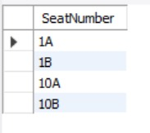
📌 3. Flight Search by Route/Date
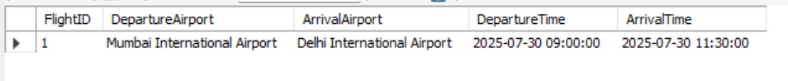
📌 4. Booking Summary Report
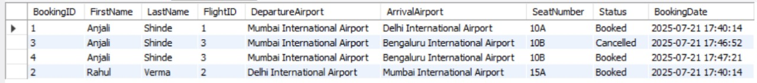
📌 5. Triggers Created
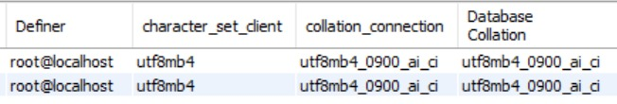
✅ Conclusion
The Airline Reservation System was successfully designed and implemented.
It demonstrates a normalized relational schema with real constraints, data integrity, automation using triggers, and simple yet practical reporting using SQL queries and views.
This shows a clear understanding of SQL concepts, good design practice, and practical usage for a real-world scenario.

✅ Submitted By
Name: ANJALI SHINDE
Semester: 3RD YEAR 1ST SEM
Date: 21-07-2025

